1. Define the following terms associated with game theory:
1. Dominant strategy.
A dominant strategy is defined as an ordered sequence of a player where he/she receives highest payoff despite the performance of the other player.
2. Nash equilibrium
Nash equilibrium as in game theory describes the best stage of the game where both participants in the game make ideal moves but considers what the moves of the opponents are.
3. Mixed strategy
A prayer is said to use this mixed strategy in the game theory, when he or she has a set of available actions but chooses them randomly in the game.
4. First mover advantage
A player will only enjoy this advantage if he/she upon achieving a high payoff will make the game into an ordered one where he must be the first mover as long as the game course is changed

2. Two Airline, Uptown and RareAir, are trying to decide whether to charge low or high prices for airline tickets. The payoffs are described in the following diagram
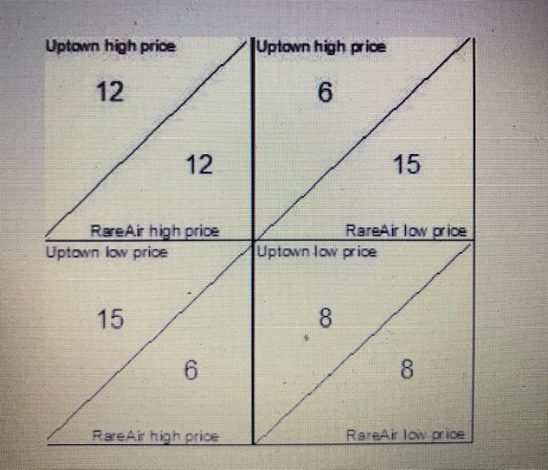
3. Two companies, D company and C Company, have the option of charging either a high price or low price for their products. Here are the profits that each company will make in each circumstance:
Describe whether each company will charge a low or high price. What type of strategy does each company have (dominant, mixed)? Is there a Nash equilibrium?

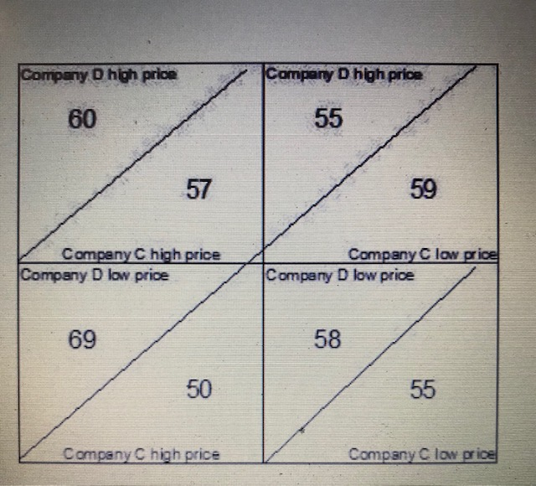
Company A will charge high price while Comapnay D will charge Low price. Company A will apply the dorminant strategy since there will higher payoff regardless of what company C does yet company C may blindly follow company A. in examining each action profile of each company, Since company D can increase her pay off by opting different action from the current, hence there is no Nash Equilibrium.

